**Experiment 1.1**

**Student Name:   Gaurav Kumar                                UID: 22MCC20177**

**Branch:   CC-DevOps                                                     Section/Group:- 1/B**

**Semester:   One                                                               Date of Performance: 4/11/2022**

**Subject Name:- Design & Analysis of Algorithms Lab                   Subject Code: 22CAP-646**

1. **Task to be done:**

Sort a given set of elements in ascending order using the Quick sort method and determine the time required to sort the elements. Take A= {13,24,55,10,64,31,7,4,15,6} as input The number of elements in the list to be sorted and plot a graph of the time taken.

1. **Steps for experiment/practical: copy and paste your code here/screenshots**

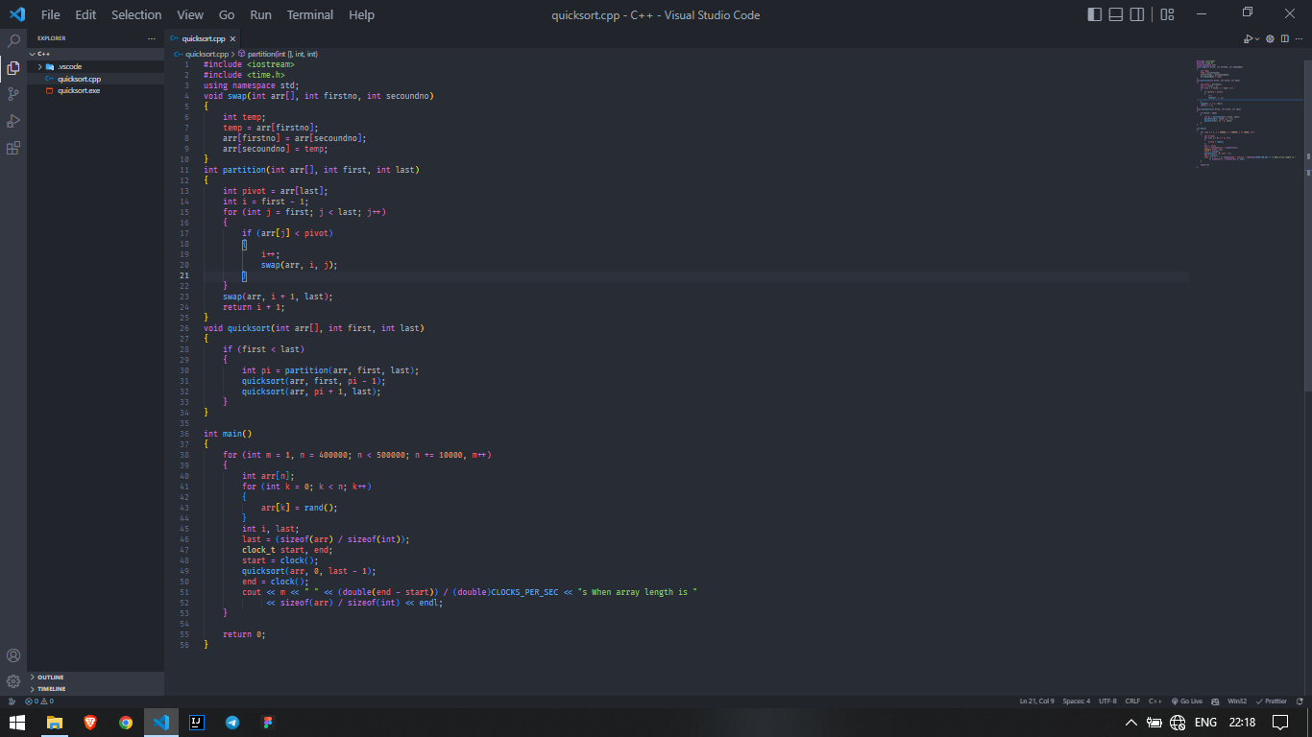

1. **Output (screenshots)**

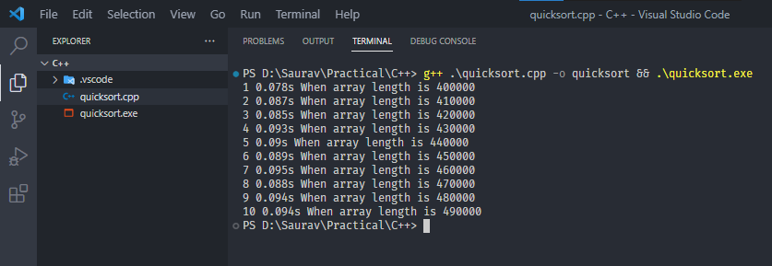

**4) Learning outcomes (What I have learnt): Times new roman 12 size**

**1. Divide and Conquer Rule**

**Evaluation Grid:**

|  |  |  |  |
| --- | --- | --- | --- |
| Sr. No. | Parameters | Marks Obtained | Maximum Marks |
| 1. | Demonstration and Performance  (Quiz) |  | 22 |
| 2. | Worksheet |  | 8 |